Station 1

Using a compass and straightedge, construct a line perpendicular to line segment AB

Station 2

Using a compass and straightedge, construct an angle congruent to the given angle

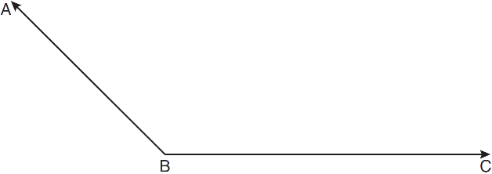

Station 3

Using a compass and straightedge, construct an isosceles triangle with a base of length x and a leg of length y

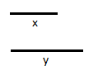

Station 4
On the poster paper do the following:
- Part I
  - Create your own line segment using a straightedge
  - Create a reference line using a straightedge
  - Using a compass and straightedge, construct an equilateral triangle
- Part II
- Create an obtuse angle
- Bisect the angle
- Write step by step directions that someone can use to bisect an angle

Your poster will be displayed and should be colorful and neat.

RUBRIC

 | 5 | 3 | 2
Participation | Student was actively engaged in the activity during the entire period. | Student was actively engaged in the activity for part of the period. | Student was not actively engaged in the activity during the period.
Accuracy | All constructions were correct. | One construction was incorrect. | More than one construction was incorrect.
Poster | Poster was colorful/neat and included all steps for the construction. | Poster was colorful/neat but was missing a step for the construction. | Poster was not colorful/neat  And/or  Poster was missing more than one step for the construction.
Deadline | Student handed in project on time. | Student handed in project 1-2 days late. | Student handed in project 3-5 days late.  *Students who hand in a project more than 5 school days late will not receive any points for the category.

